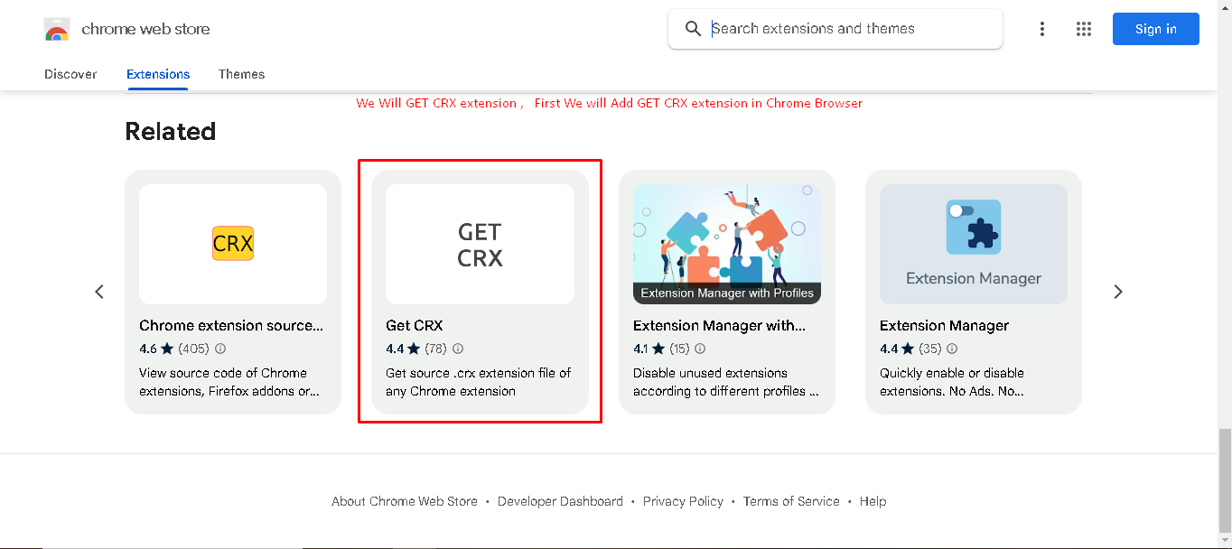

Step 1 . Add GET CRF extension in Browser

Step 2. Than Search What Ever Extension WhatEver you want to Add

For e.g. Selector Hub, Test Case Studio , etc.

Step 3. Right Click within Webstore or Browser area and Click on Get CRX of this extension

Step 4. It will automatically download Selector Hub or Test Case Studio or Whatever extension you want to add

Step 5:- Copy that Downloaded Selector Hub or Test Case Studio or Whatever you added and than Paste into your Eclipse project path anywhere

Within your project, Probably you can create new folder within your project as Extension and Paste there Selector Hub

